# Balance transfer failures

[Errors during settlement](https://wiki.scn.sap.com/wiki/display/ERPFI/Errors+during+settlement)

# ****KD256: There are no accrued amounts; settlement is not possible.****

In general, RA data is calculated and settled until statuses TECO or DLV are active in the order. As soon as any of these two statuses is active in the order, Settlement of actual costs takes place.

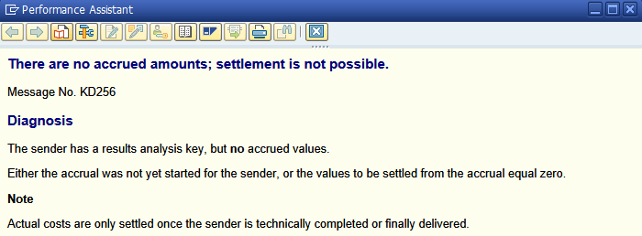

This error happens because there are missing calculations or customizing in Results analysis (OKG* transactions). If the order (controlling object, in general) **carries a Results Analysis key**, please, perform the following checks:

1. Check if WIP / RA data has been calculated for the order (data appears in table COSB).
2. Check if WIP has already been settled, so there will be no delta from the previous settlement of RA data.
3. Check if the there are posting rules maintained for the CO Area, RA version... in the customizing (OKG8).
4. Check if any of the RA versions has flag "Transfer to financial accounting" set (transaction OKG2).

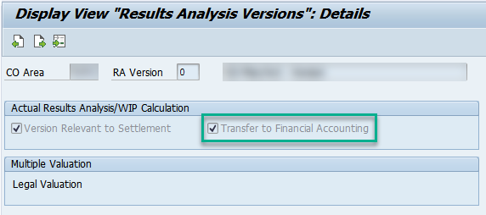

If any of the checks above fails, KD256 error will correctly prompt.

# ****KD213: Either the sender is already settled, or there is nothing to settle****

When settling a CO Object for a specific posing period-fiscal year, the settlement code will be executed if the balance of the order **is not zero**. Otherwise, KD213 will prompt. However, there are some considerations depending on the settlement rule type (check this [link](https://wiki.scn.sap.com/wiki/x/TYjHGg) for more detailed information):

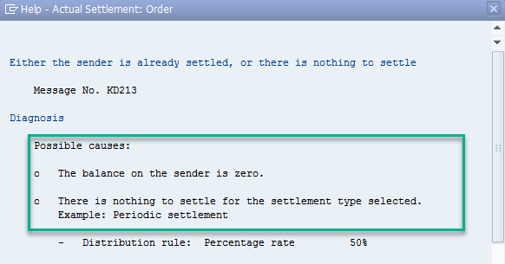

* FUL rule: If the order has a full rule, the balance of the order is actually zero.
* PER rule: if the order has a periodic rule the following scenarios can take happen:

1. Total balance of the order may be zero.
2. The balance of the order is zero **in the settlement period**. For example, your current period is 07/2017 and you are trying to settle period 06/2017 where there is no balance.
3. The balance of the order is zero **in the settlement period**but there is a remaining balance from previous unsettled periods, which prevents the order to be closed. This unsettled balance can be displayed via the execution of report COPCOBJ_REORGCHECK (find more detailed information in SAP note [421710](https://launchpad.support.sap.com/#/notes/421710/E)). In this case, if current period was 07/2017 and you had a balance in 06/2017 and zero in 07/2017, you will obtain KD231 error when settling 07/2017 and the foreseen report would show the existing balance in 06/2017.

In case of FUL scenario, it is straightforward there is nothing to settle because the balance of the order is 0. However for PER scenario, there are two possible solutions (if there is an unsettled balance from previous periods) described the following SAP notes:

* [140672](https://launchpad.support.sap.com/#/notes/140672/E) - Info: Settle/reverse costs from previous periods
* [2397593](https://launchpad.support.sap.com/#/notes/2397593/E)  - How to settle costs from previous year (cross-year settlement)?

**Note**: To avoid this error with **new orders**, it is highly recommended to use a **FUL rule towards a PER rule** when using periodic scenario. If this is not suitable for your production scenario, when settling orders with PER rule, it is also recommended to use **full settlement processing type** (option to choose at the beginning of the settlement transaction). If this option is selected, the system will return an error if there is unsettled balance from previous periods, so you can correct the relevant order/s, possibly by reversing the settlements of the current period and settling the previous period again.

# ****KD216: No Settlement document exists****

When running the settlement application for a controlling object (KO88, CJ88...) error KD216 prompts saying there is no settlement document. This error happens in two scenarios:

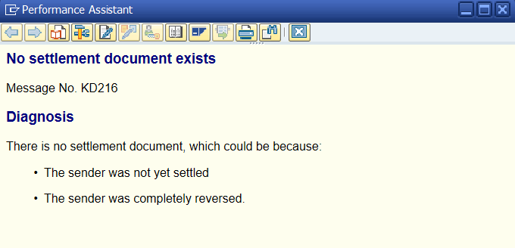

1. The sender was not yet settled. You are trying to reverse the settlement document of a posting period/fiscal year which does not exist.
2. The sender was completely reversed. You are trying to reverse the settlement document of a posting period/fiscal year, which has already been reversed.

# ****KD258: Final delivery not entered for the order. It is not technically completed.****

When settling an order for a specific period-fiscal year, KD258 error happens because the order has status DLV/TECO in a **period after the settlement period**. For example, your are settling 01/2018 & the order has any of these two statuses active in period 02/2018.

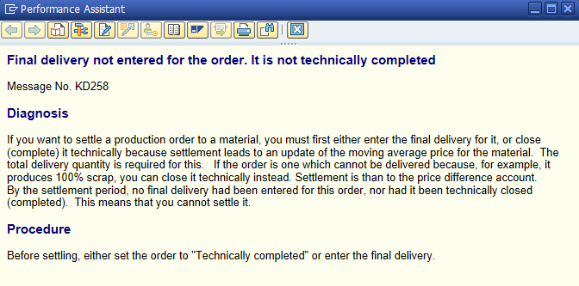

Actually, the order is completed, either Technically or because of final delivery. Therefore, the system expects to have any of the foreseen statuses active in the settlement period. These statuses are stored in AUFK-IDAT2 (TECO) and AFPO-LTRMI (DLV). A more detailed explanation about the logic to update these statuses can be found in SAP Note [530563](https://launchpad.support.sap.com/#/notes/530563/E).

In this scenario, the order can only be settled **in a period where TECO/DLV status is active**. As possible workaround, you can revoke the status of technical completion of the production order and post a GR with posting data in previous period (with the dates in the example above, period 01/2018) with quantity 0. Also, you should set the flag 'delivery completed'. As a result, the field AFPO-LTRMI will be filled with a date in previous period.

# ****KD285: Status DLV/TECO was reversed after settlement of period mmm/yyyy.****

When settling an order for a specific period-fiscal year, KD285 error happens because the status DLV/TECO has been reversed since last settlement. In other words, the last time the order was settled it had status DLV/TECO and, currently, non of the two are active for the order.

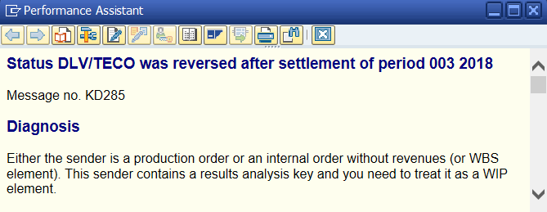

This status is reset as a result of new material movements posted after the settlement, which cause a balance in the order. To settle this new balance, please, reverse the previous settlement and settle the order again. Depending on your MM customizing or if you are using the ML, there may not be possible to reverse the settlement in the settlement period, so you should post it into current period.

For example, you settled the order in period 003/2018 and current period is 004/2018. Either for your MM customizing, either because of using the Material Ledger with actual costing (after period-end closing, price control of previous period can be changed from S to V after the revaluation step, so prior and current period will differ), you cannot reverse the posting of 003.2018 into this same period. In such case reverse the settlement into current period as follows:

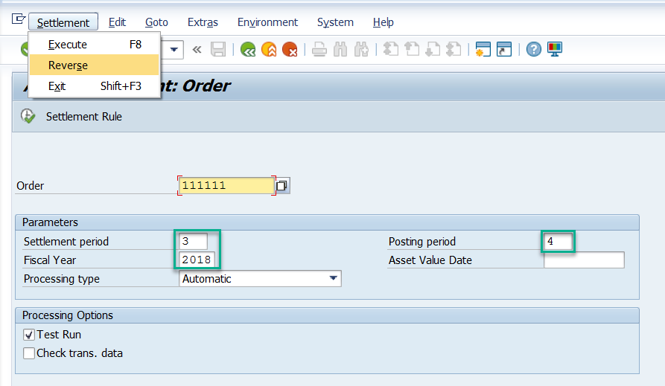

# ****KD527: Settlement document: The system issued the last document number****

When settling an order for a specific posing period-fiscal year, KD527 error happens because object CO_ABRECHN has reached the **highest number of the number range**. Now, the system tries to start from the begining of the interval, which causes a **duplication** of entries in table AUAK.

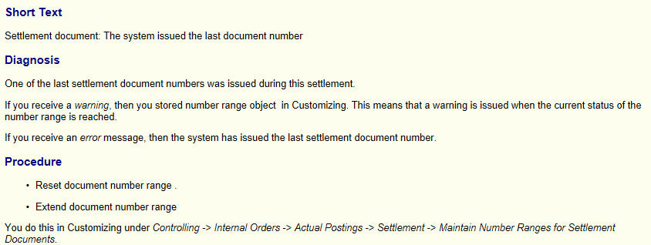

In this scenario, there are two options (see SAP Note [1870037](https://launchpad.support.sap.com/#/notes/1870037/E)) to solve this issue:

1. **Archive and delete** the existing settlement documents for which the settlement documents would be repeated.
2. **Extend the number range**. If this second option is chosen, please, extend the number range of CO_ABRECHN in transaction SNRO. If the object has **main memory buffering**, reseting the buffers in all the instances of the system is also necessary. Otherwise, the system will put in the buffer numbers that will cause again a **dump** because of duplicate entries. To do so, please, follow these steps (SAP Note [741698](https://launchpad.support.sap.com/#/notes/741698/E)):

During main memory buffering, you do not need to reorganize using transaction SNRO. Instead, use transaction SM56 to reset the number range buffer:

* + - * Call transaction SM56.
      * Choose the menu option "Number Range Buffer -> Reset".

A dialog box in which you can enter all the information is displayed.  
Caution: The generic entry is blank, not '*'.  
You must also set the "Global Reset" indicator so that all instances are synchronized.

# ****KD529: Correct your material distribution rules.****

When settling a product cost collector for a specific posting period-fiscal year, KD529 happens when the settement rule has more than one distribution rule to material:

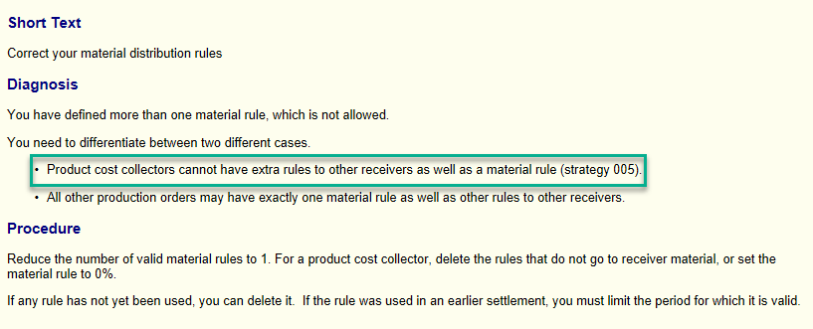

The settlement rule of a product cost collector can only have one distribution rule where, the receiver, **must be the produced material**. In other words, unlike regular production orders, product cost collectors can only be settled to materials.

To solve this error, in general, you should remove the additional distribution rule/s from the settlement rule, leaving only the material as receiver of the settlement. If it is not possible to delete this extra distribution rule/s, you can set the extra distribution rule/s to 0% and the material rule to 100%.

# ****CK122: Invalid posting period (please check your entry)****

When settling a sender, the settlement period can be different than current period in FI but there is a prerequisite: **the posting period has to be after the settlement period** and the settlement period and posting period have to be in the **same** fiscal year, which must be the current one. This means that a cross-year settlement is **not** possible in the standard product delivered by SAP.

Regarding this error there are two possible approaches to solve it:

* Without a modification: See KBA [2165419](https://launchpad.support.sap.com/#/notes/2165419/E) - Error CK122 happens in T-code: CO88/KO88
* With a modification: See KBA [2397593](https://launchpad.support.sap.com/#/notes/2397593/E) - How to settle costs from previous year (cross-year settlement)? If you choose this option, please consider all the constraints suggested on it, as it is not suitable for all the scenarios, for example, when settling fixed assets.

# ****CK426: Valuation type not set for material XXXX****

This error happens because, at the time of the settlement,  no valuation segment type exists for the material. This segment is created automatically by the system at the time of the delivery.

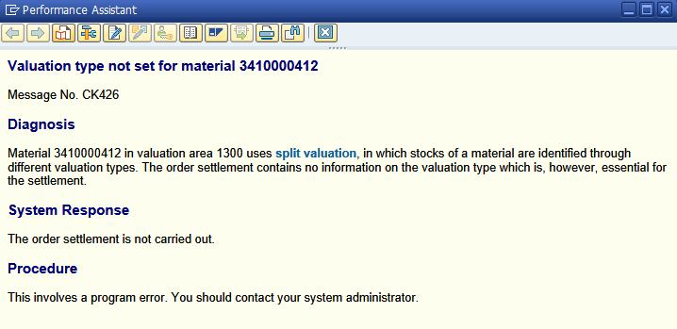

During settlement the system would be trying to post costs to a material which does not exist. Also, the order settlement contains no information on the valuation type which is essential for the settlement.

SAP note [150605](https://launchpad.support.sap.com/#/notes/150605/E) explains the possible solutions to this error.